Lab experiment

5.Construct a scheduling program with C that selects the waiting process with the highest priority to execute next.
Aim:
To write and execute a C program that selects the waiting process with the highest priority to execute next using the Priority Scheduling algorithm.

Algorithm:
1.Start the program.
2.Read the number of processes.
3.Read the burst time and priority of each process.
4.Arrange the processes in ascending order of priority, where a smaller number indicates a higher priority
5.Calculate the waiting time of each process.
6.Calculate the turnaround time using TAT = WT + BT.
7.Calculate the average waiting time and average turnaround time.
8.Display the process details and calculated times.
9.Stop the program.

Coding:

#include <stdio.h>

int main()
{ int n, i, j, temp; int pid[20], bt[20], priority[20]; int wt[20], tat[20];
float avg_wt = 0, avg_tat = 0;

printf("Enter number of processes: "); scanf("%d", &n);

for (i = 0; i < n; i++)
{ pid[i] = i + 1; printf("Enter burst time and priority of P%d: ", pid[i]); scanf("%d %d", &bt[i], &priority[i]);
}

/* Sort processes by priority */ for (i = 0; i < n - 1; i++)
{ for (j = i + 1; j < n; j++)
{ if (priority[i] > priority[j])
{ temp = priority[i]; priority[i] = priority[j]; priority[j] = temp;
temp = bt[i]; bt[i] = bt[j]; bt[j] = temp;
temp = pid[i]; pid[i] = pid[j]; pid[j] = temp;
}
}
}

wt[0] = 0;

for (i = 1; i < n; i++) wt[i] = wt[i - 1] + bt[i - 1];

for (i = 0; i < n; i++)
{ tat[i] = wt[i] + bt[i]; avg_wt += wt[i]; avg_tat += tat[i];
}

printf("\nPID\tBT\tPriority\tWT\tTAT\n");

for (i = 0; i < n; i++)
{
printf("P%d\t%d\t%d\t\t%d\t%d\n",
pid[i], bt[i], priority[i], wt[i], tat[i]);
}

printf("\nAverage Waiting Time = %.2f\n", avg_wt / n); printf("Average Turnaround Time = %.2f\n", avg_tat / n);

return 0;
}

Output:

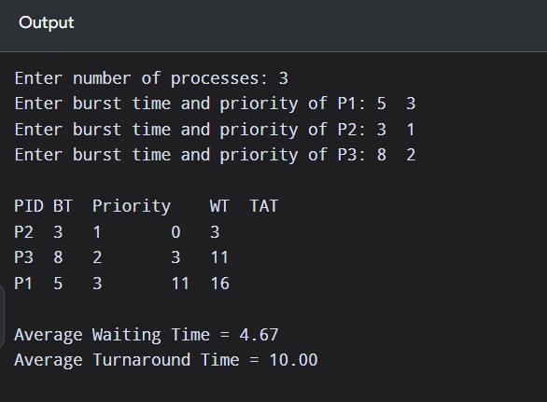

Result:
Thus, the C program for Priority Scheduling in an Operating System was successfully implemented and executed. The processes were scheduled according to their priorities, and the waiting time and turnaround time were calculated.

